GroundCrew.AI Stage 2

- In the Microsoft Copilot Studio Page, ensure you change your environment to the same environment as the one you created your power apps table in (Highly important step )

- In the Microsoft copilot studio page, click on the “Create” button at the taskbar on the left side, then click “New agent”
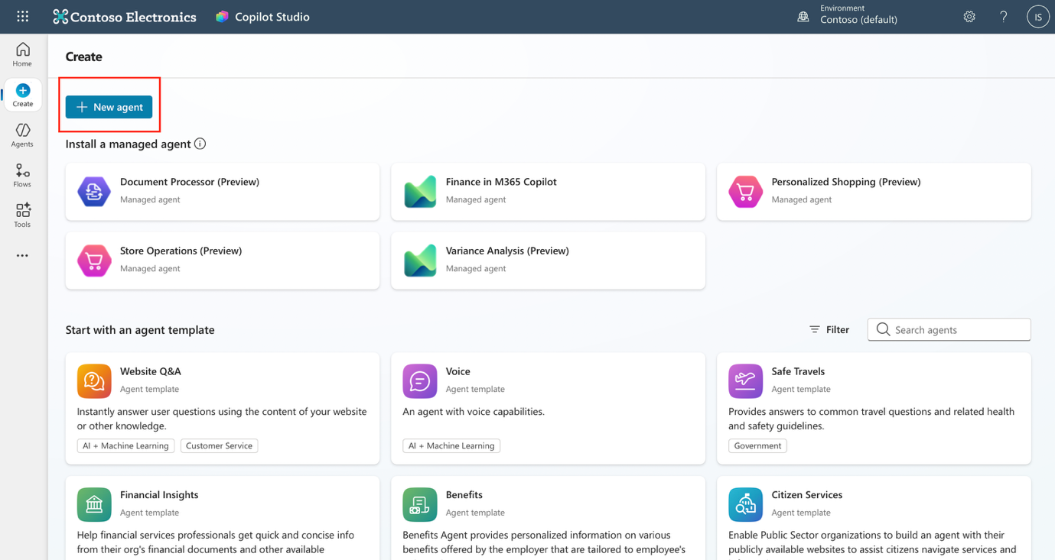

- On the “Describe” tab enter this prompt:
“I want to create a pre-onboarding agent that would assist a new hire with activities such as email verification and headshot uploading. The agent should also be able to answer any HR or pre-onboarding questions from the knowledge base”
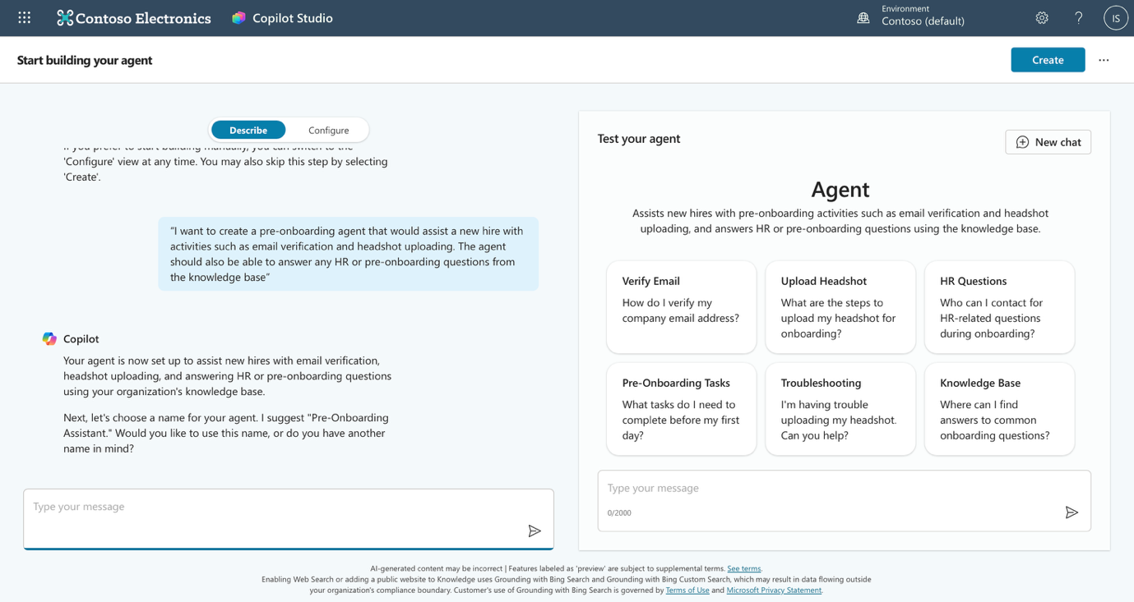
Copilot should build the basics for the agent for you as shown in the image. Give it a name of your preference or just say “ok” to the suggested name.

- After you are done click the ‘create’ button on the top right

- Click “Knowledge” on the top taskbar

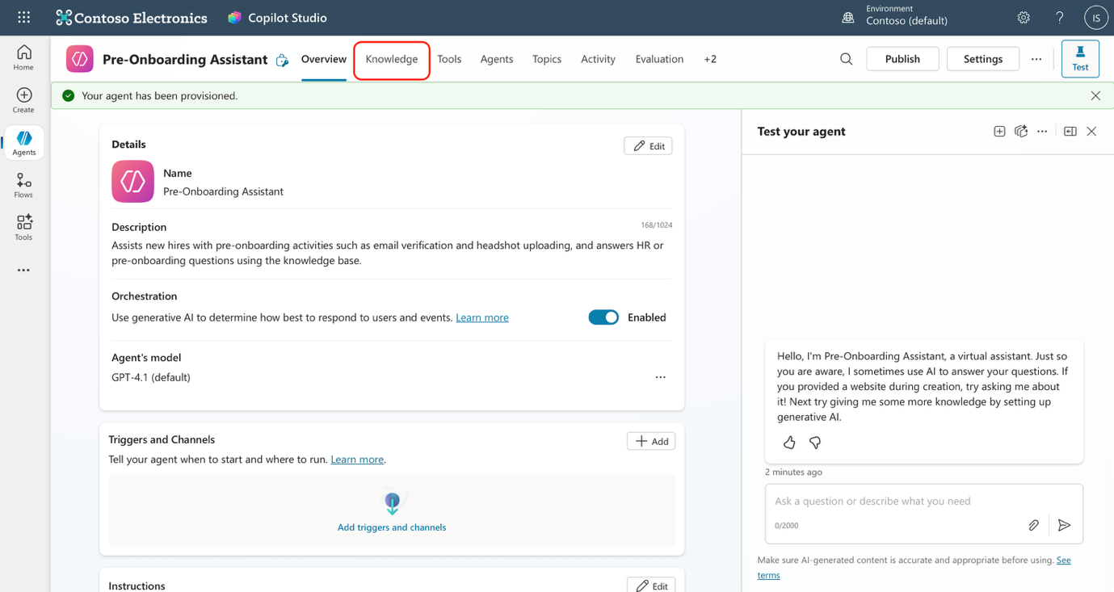

- Click “Add Knowledge”

- Choose to add from SharePoint
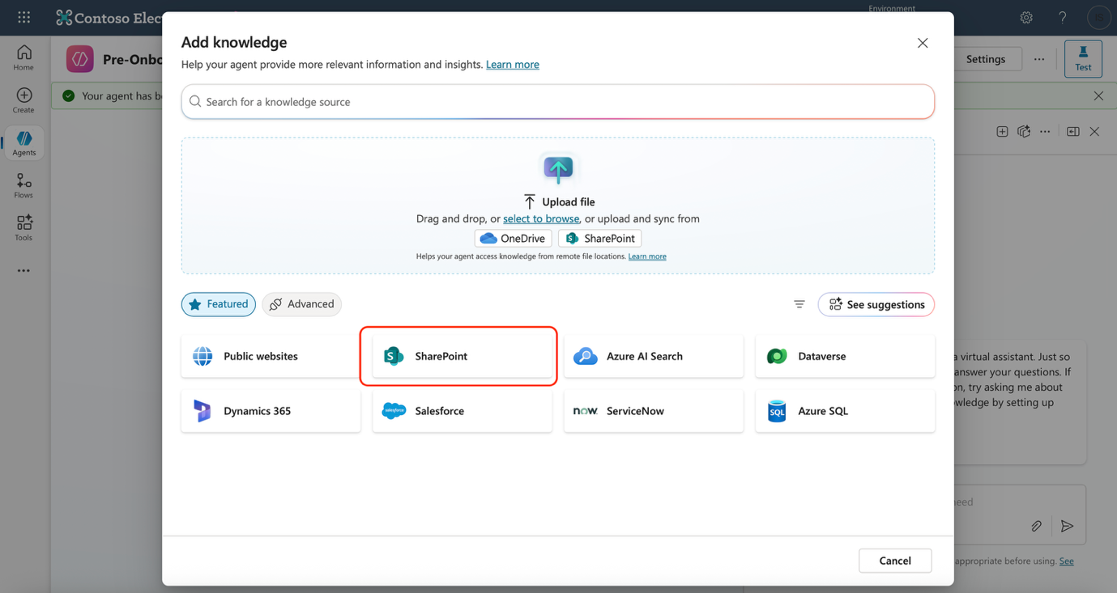

- On the pop up window, choose to ‘browse items’

- You will be brought this page, click on ‘The Landing’ and select JTC AI Demo folder , select all 3 files in the folder and click “Confirm selection” and “Add to agent”
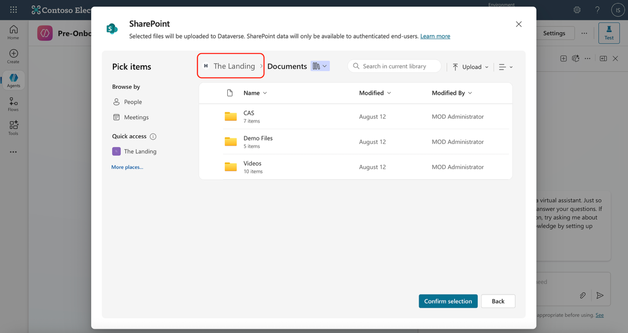

- You should see that all your files are added to the knowledge and ready to be queried!
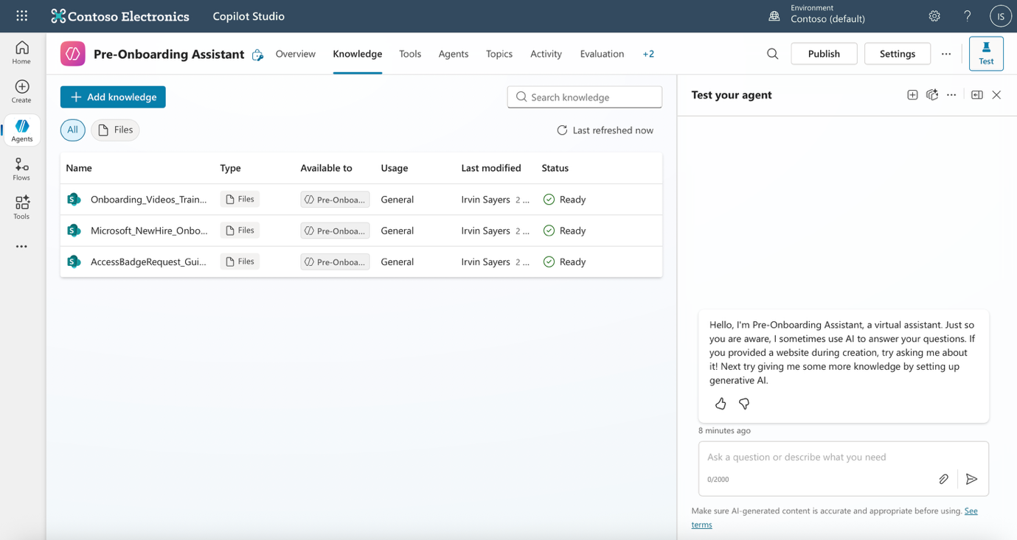

- Test your agent on the test pane on the right side of your window, Use “What are the onboarding processes I can expect” or any other prompt of your choice!
- Well done! You have now created an agent and added knowledge base to it, enabling it to answer any user query in a conversation!

